Chapter 08: Material Planning (MP)

Exercise 08-02: Material Planning Process

Multiple Company Code

Version 4.14

Revised 07/27/2015

Introduction

General Notes and Information

It is strongly recommended that you read through the entire exercise prior to starting. Not all instructions can be provided in a linear manner in the exercise itself. READ CAREFULLY!

The following symbols are used to indicate important information as described below.

* An arrow highlights an important instruction that must not be overlooked.

🖉 A pencil prompts you to write down an important piece of information.

Each student or group will be assigned a unique two-digit identifier. This identifier is used in all exercises. Whenever you see ##, replace it with your identifier. For example, Joe may have an identifier of 05. Every time Joe sees the ## symbol, he will replace it with “05”.

**Differences in Font**:Throughout this exercise you will see tables with different fonts used in the Data Entry column(s). The normal Times New Roman indicates you enter exactly what is typed out except for the ## Symbol where you would put in your identifier. The italicized *Times New Roman* font indicates the data is looked up, found, or otherwise not to be entered literally as written.

* Always work with your data.

Business Process Overview

GBI utilizes the material planning process to develop forecasts and to create sales plans. After successfully implementing material planning, GBI can automate its planning through an MRP run which will automatically create purchase requisitions and planned orders for production. This exercise will take you through this process of planning for materials and then ordering.

Exercise Prerequisites

Chapter 08-01 Version MCC 4.10

Exercise Workflow

Exercise Deliverables

Deliverables are consolidated into one worksheet at the end of the exercise. It is only necessary to turn in that worksheet and that worksheet alone along with data in the system if required.

For this exercise you will need the following deliverables:

In the System:

* SOP Plan Created
* SOP Plan Disaggregated
* Plans Transferred
* MRP Run at Product Group Level Completed
* MRP Run at Material Level Completed
* Orders Converted

On Paper:

* Answer(s) to Question(s)
* Document Number(s)
* You may be assigned additional deliverables. Make certain to check with your instructor.

Step 1: Create SOP Plan

Throughout this exercise, you figure out how much raw materials are needed just by having the sales demand data of the product group. In this step, you create a sales and operation plan (the sales demand) for the bicycle product group. This plan triggers many processes as you will see.

GBI’s CEO, John Davis, has just returned from a trade show where he displayed the company’s products. He is very excited because he received a great deal of positive feedback. Based on his conversations with several potential customers, he anticipates that sales will increase over the next few months. In this step, you create a sales plan based on John’s period projections.

1. In the “SAP Easy Access” screen, follow the navigation path below:

Navigation

Logistics à Production 🡪 SOP 🡪 Planning 🡪 For Product Group 🡪 Change

1. What is the transaction code to change an SOP plan for a product group? MC82 🖉
2. In the “Change Plan: Initial Screen” screen, enter the following information:

|  |  |
| --- | --- |
| Field Name | Data Entry |
| Product group | Your Product Group Bicycles |
| Plant | Your Plant Dallas |

1. Click on  (ACTIVE VERSION).
2. In the “Change Rough-Cut Plan” screen, enter the following information:

|  |  |  |  |
| --- | --- | --- | --- |
| Planning table | Next Period/Year | Two Periods Later/Year | Three Periods Later/Year |
| **Sales** | 1200 | 1200 | 850 |
| **Target stock level** | 800 | 800 | 600 |

1. Click on  (ENTER).

* Notice the stock level line is filled with negative numbers because there is no plan for production. Use the following information to fill in the line for the target stock level.

1. Enter the following information:

|  |  |  |  |
| --- | --- | --- | --- |
| Planning table | Next Period/Year | Two Periods Later/Year | Three Periods Later/Year |
| **Production** | 2000 | 1200 | 650 |

1. Click on  (ENTER).

* The stock level line is now the same as the target stock level line.

1. Click on  (SAVE).

You will receive a message that says “Plan saved under version number”.

Exercise Deliverables:

In the System:

* SOP Plan Created

On Paper:

* Answer(s) to Question(s)

Step 2: Disaggregate SOP Plan

In this step, we will disaggregate the production plan we created in SOP down to the material level. Using the proportion factors we set up in our original product group, the system will do all the work for us, deciding how many of each part we need to meet the production needs.

1. In the “SAP Easy Access” screen, follow the navigation path below:

Navigation

Logistics 🡪 Production 🡪 SOP 🡪 Disaggregation 🡪 Break Down PG Plan

1. What is the transaction code to break down a product group plan? MC76 🖉
2. In the “Change Plan: Initial Screen” screen.

Enter the following information:

|  |  |
| --- | --- |
| Field Name | Data Entry |
| Product group | Your Product Group Bicycles |
| Plant | Your Plant Dallas |

1. Click on the  icon.
2. In the “Change Plan: Initial Screen” pop-up, click on the  icon.

* The window should display the plan that you created for your product group.
* Now, you will begin to disaggregate the plans down to the material level.

1. In the “Change Rough-Cut Plan” pop-up, click on the  icon.
2. You are in the “Macro Selection” pop-up.

Click on Disaggregate Production -> Production.

1. Click on  (CONTINUE (ENTER)).

* The plan has now been disaggregated down to the next level within the bike product group.

1. Click on  (SAVE).

You will receive a message that says “Plan saved under version number”.

1. In the “Change Plan: Initial Screen” screen, enter the following information:

|  |  |
| --- | --- |
| Field Name | Data Entry |
| Product group | Your Product Group OffRoad Bicycles |

1. Click on  (ACTIVE VERSION).
2. In the “Change Plan: Initial Screen” pop-up, click on the  icon.
3. In the “Change Rough-Cut Plan” pop-up, click on the  icon.
4. You are in the “Macro Selection” pop-up.

Click on Disaggregate Production -> Production.

1. Click on  (CONTINUE (ENTER)).

* The plan has now been disaggregated down to the next level within the bike product group.

1. Click on  (SAVE). You will receive a message that says “Plan saved”.
2. In the “Change Plan: Initial Screen” screen, enter the following information:

|  |  |
| --- | --- |
| Field Name | Data Entry |
| Product group | Your Product Group Touring |

1. Click on  (ACTIVE VERSION).
2. In the “Change Plan: Initial Screen” pop-up, click on the  icon.
3. In the “Change Rough-Cut Plan” pop-up, click on the  icon.
4. You are in the “Macro Selection” pop-up.

Click on Disaggregate Production -> Production.

1. Click on  (CONTINUE (ENTER)).
2. Click on  (SAVE). You will receive a message that says “Plan saved”.
3. In the “Change Plan: Initial Screen” screen, enter the following information:

|  |  |
| --- | --- |
| Field Name | Data Entry |
| Product group | Your Product Group Deluxe Touring Bicycle |

1. Click on  (ACTIVE VERSION).
2. In the “Change Plan: Initial Screen” pop-up, click on the  icon.
3. In the “Change Rough-Cut Plan” pop-up, click on the  icon.
4. You are in the “Macro Selection” pop-up.

Click on Disaggregate Production -> Production.

1. Click on  (CONTINUE (ENTER)).
2. Click on  (SAVE). You will receive a message that says “Plan saved”.
3. In the “Change Plan: Initial Screen” screen, enter the following information:

|  |  |
| --- | --- |
| Field Name | Data Entry |
| Product group | Your Product Group Professional Touring |

1. Click on  (ACTIVE VERSION).
2. In the “Change Plan: Initial Screen” pop-up, click on the  icon.
3. In the “Change Rough-Cut Plan” pop-up, click on the  icon.
4. You are in the “Macro Selection” pop-up.

Click on Disaggregate Production -> Production.

1. Click on  (CONTINUE (ENTER)).
2. Click on  (SAVE). You will receive a message that says “Plan saved”.

Exercise Deliverables:

In the System:

* SOP Plan Disaggregated

On Paper:

* Answer(s) to Question(s)

Step 3: Transfer Plans

In this step, you transfer your disaggregated plans to demand management.

1. In the “SAP Easy Access” screen, follow the navigation path below:

Navigation

Logistics 🡪 Production 🡪 SOP 🡪 Disaggregation 🡪 Transfer PG to Demand Management

1. What is the transaction code to transfer the groups to demand management? MC75 🖉
2. You are in the “Transfer Planning Data to Demand Management” screen.

Enter the following information:

|  |  |
| --- | --- |
| Field Name | Data Entry |
| Product group | Your Product Group Bikes |
| Version | *Active version* |
| Production plan for material or PG members | Selected |
| From | First Day of Next Period |
| To | Last Day of Three Periods from Now |
| Requirements type | *Make-to-stock production* |

1. Click on  (TRANSFER NOW).

* You will not receive any type of confirmation or message that you have successfully transferred your product group. If you already have enough material to meet the requirements, you will be brought to a screen with an error.

Exercise Deliverables:

In the System:

* Plans Transferred

On Paper:

* Answer(s) to Question(s)

Step 4: Complete MRP Run at Group Level

In this step, you execute the MRP runs. GBI wants to carry out planning for all materials that have undergone a change relevant to the SOP disaggregation. After the MRP is completed, planned orders or purchase requisitions will be created for materials depending on their MRP type. In addition, schedule lines will be created in the periods that we are not yet in.

1. In the “SAP Easy Access” screen, follow the navigation path below:

Navigation

Logistics 🡪 Production Process 🡪 Production Planning 🡪 MPS 🡪 MPS 🡪 Single Item, Interactive

1. What is the transaction code for single-item planning, interactive? MD43 🖉
2. You are in the “Single-Item Planning - Interactive -” screen.

Enter the following information:

|  |  |
| --- | --- |
| Field Name | Data Entry |
| Material | Your Product Group Bicycles |
| Product group | Selected |
| Create purchase req. | *Planned orders* |

1. Click on  (ENTER).

You will receive a message that says “Please check input parameters”.

1. Click on  (ENTER).
2. You are in the “Product Group PG-BIKE0## DL##” pop-up.

Follow the navigation path below:

Navigation

PG-TRBK0##🡪 PG-DXTR0## 🡪 DXTR10##

* You will need to double-click on DXTR10##.
* The next screen should display the requirements you made from transferring your plan to Demand Management.

1. You are in the “Planning Result: Individual Lines” screen.

Click on  (PLANNING).

* Notice that the system has already created a planned order for you. In addition, it has developed planned orders for the next two months to meet the target that John Davis has set.

1. How many months are planned for? 3 🖉
2. Click on  (SAVE).

You will receive a message that says “MRP carried out for DXTR10##”.

Exercise Deliverables:

In the System:

* MRP Run at Product Group Level Completed

On Paper:

* Answer(s) to Question(s)

Step 5: Complete MRP Run at Material Level

In this step, you execute the MRP runs. GBI wants to carry out planning for all materials that have undergone a change relevant to the SOP disaggregation. After the MRP is completed, planned orders or purchase requisitions will be created for materials depending on their MRP type. In addition, schedule lines will be created in the periods that we are not yet in.

1. In the “SAP Easy Access” screen, follow the navigation path below:

Navigation

Logistics 🡪 Production - Process 🡪 Production Planning 🡪 MPS 🡪 MPS 🡪 Single Item, Multi-Level

1. What is the transaction code for single-item planning, multi-level? MD41 🖉
2. In the “Single-Item, Multi-Level” screen, enter the following information:

|  |  |
| --- | --- |
| Field Name | Data Entry |
| Material | Your Deluxe Touring Bike (black) |
| Create purchase req. | *Purchase requisitions* |
| Planning mode | *Delete and recreate planning data* |

1. Click on  (ENTER).

You will receive a message that says “Please check input parameters”.

1. Click on  (ENTER).

* You have planned successfully for all materials that are necessary to produce the bike.
* In the next step, you will examine the results of your planning.

1. What is the code for the processing key for this material? NETCH 🖉

Exercise Deliverables:

In the System:

* MRP Run at Material Level Completed

On Paper:

* Answer(s) to Question(s)

Step 6: Convert Orders

In this step, you go into the stock/requirements list to view your planned materials, create purchase requisitions, and convert those purchase requisitions into a single purchase order.

1. In the “SAP Easy Access” screen, follow the navigation path below:

Navigation

Logistics 🡪 Materials Management 🡪 Material Requirements Planning (MRP) 🡪 MRP 🡪 Evaluations 🡪 Stock/Reqmts List

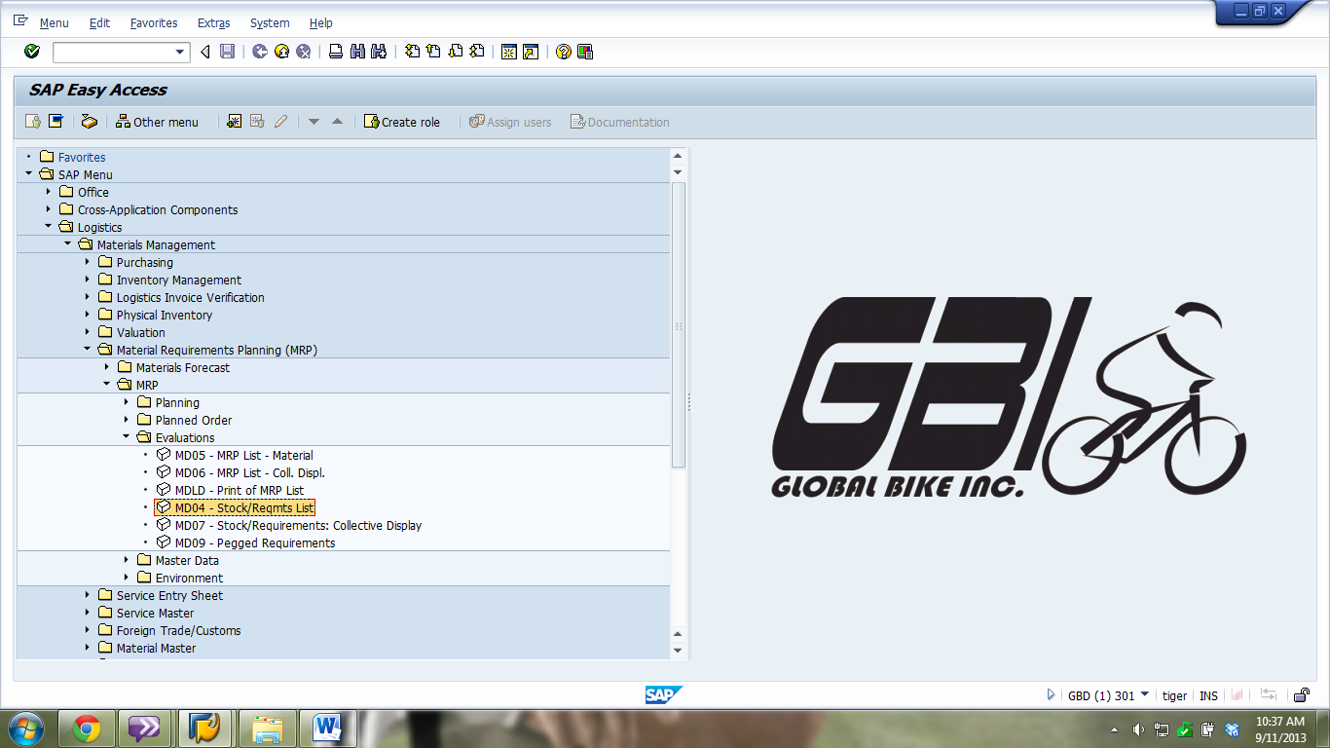

1. What is the transaction code to display a stock/requirements list? MD04 🖉
2. You are in the “Stock/Requirements List: Initial Screen” screen.

Click on the  tab.

1. Enter the following information:

|  |  |
| --- | --- |
| Field Name | Data Entry |
| Product group | Your Product Group Bicycles |

1. Click on  (ENTER).

* The result shows all eight bikes in your product group hierarchy.

1. You are in the “Stock/Requirements List: Material List” screen.

Double-click on DXTR10##.

* The stock requirements list for the black bike is displayed.

1. Double-click on the first planned order line.
2. You are in the “Additional Data for MRP Element” pop-up.

Click on  (CONVERT PLANNED ORDER TO PRODUCTION).

You will receive a message that says “Release carried out”.

1. What is the total quantity planned for this production order? 336 🖉
2. In the “Production order Create: Header” screen, click on the  icon. You will receive a message that says “Order number saved”.

* You are back in the previous screen. Refresh the data by clicking on the  icon. Notice how the order has officially changed from a planned order to a production order.

1. What is the resulting document number? 1000368 🖉

* Now, you have to procure the materials necessary to produce the black bike.
* For our purpose, it will be enough to procure just a few of the required materials.

1. In the “Stock/Requirements List as of hrs” screen, click on the  icon.
2. In the “Stock/Requirements List: Material List” screen, click on the  icon.
3. In the “Exit Material List” pop-up, click on the  icon.
4. In the “Stock/Requirements List: Initial Screen” screen.

Click on the  tab.

1. Enter the following information:

|  |  |
| --- | --- |
| Field Name | Data Entry |
| Material | Your Touring Frame-Black |

1. Click on  (ENTER).
2. Double-click on the first purchase requisition line.
3. In the “Additional Data for Element” pop-up, click on the 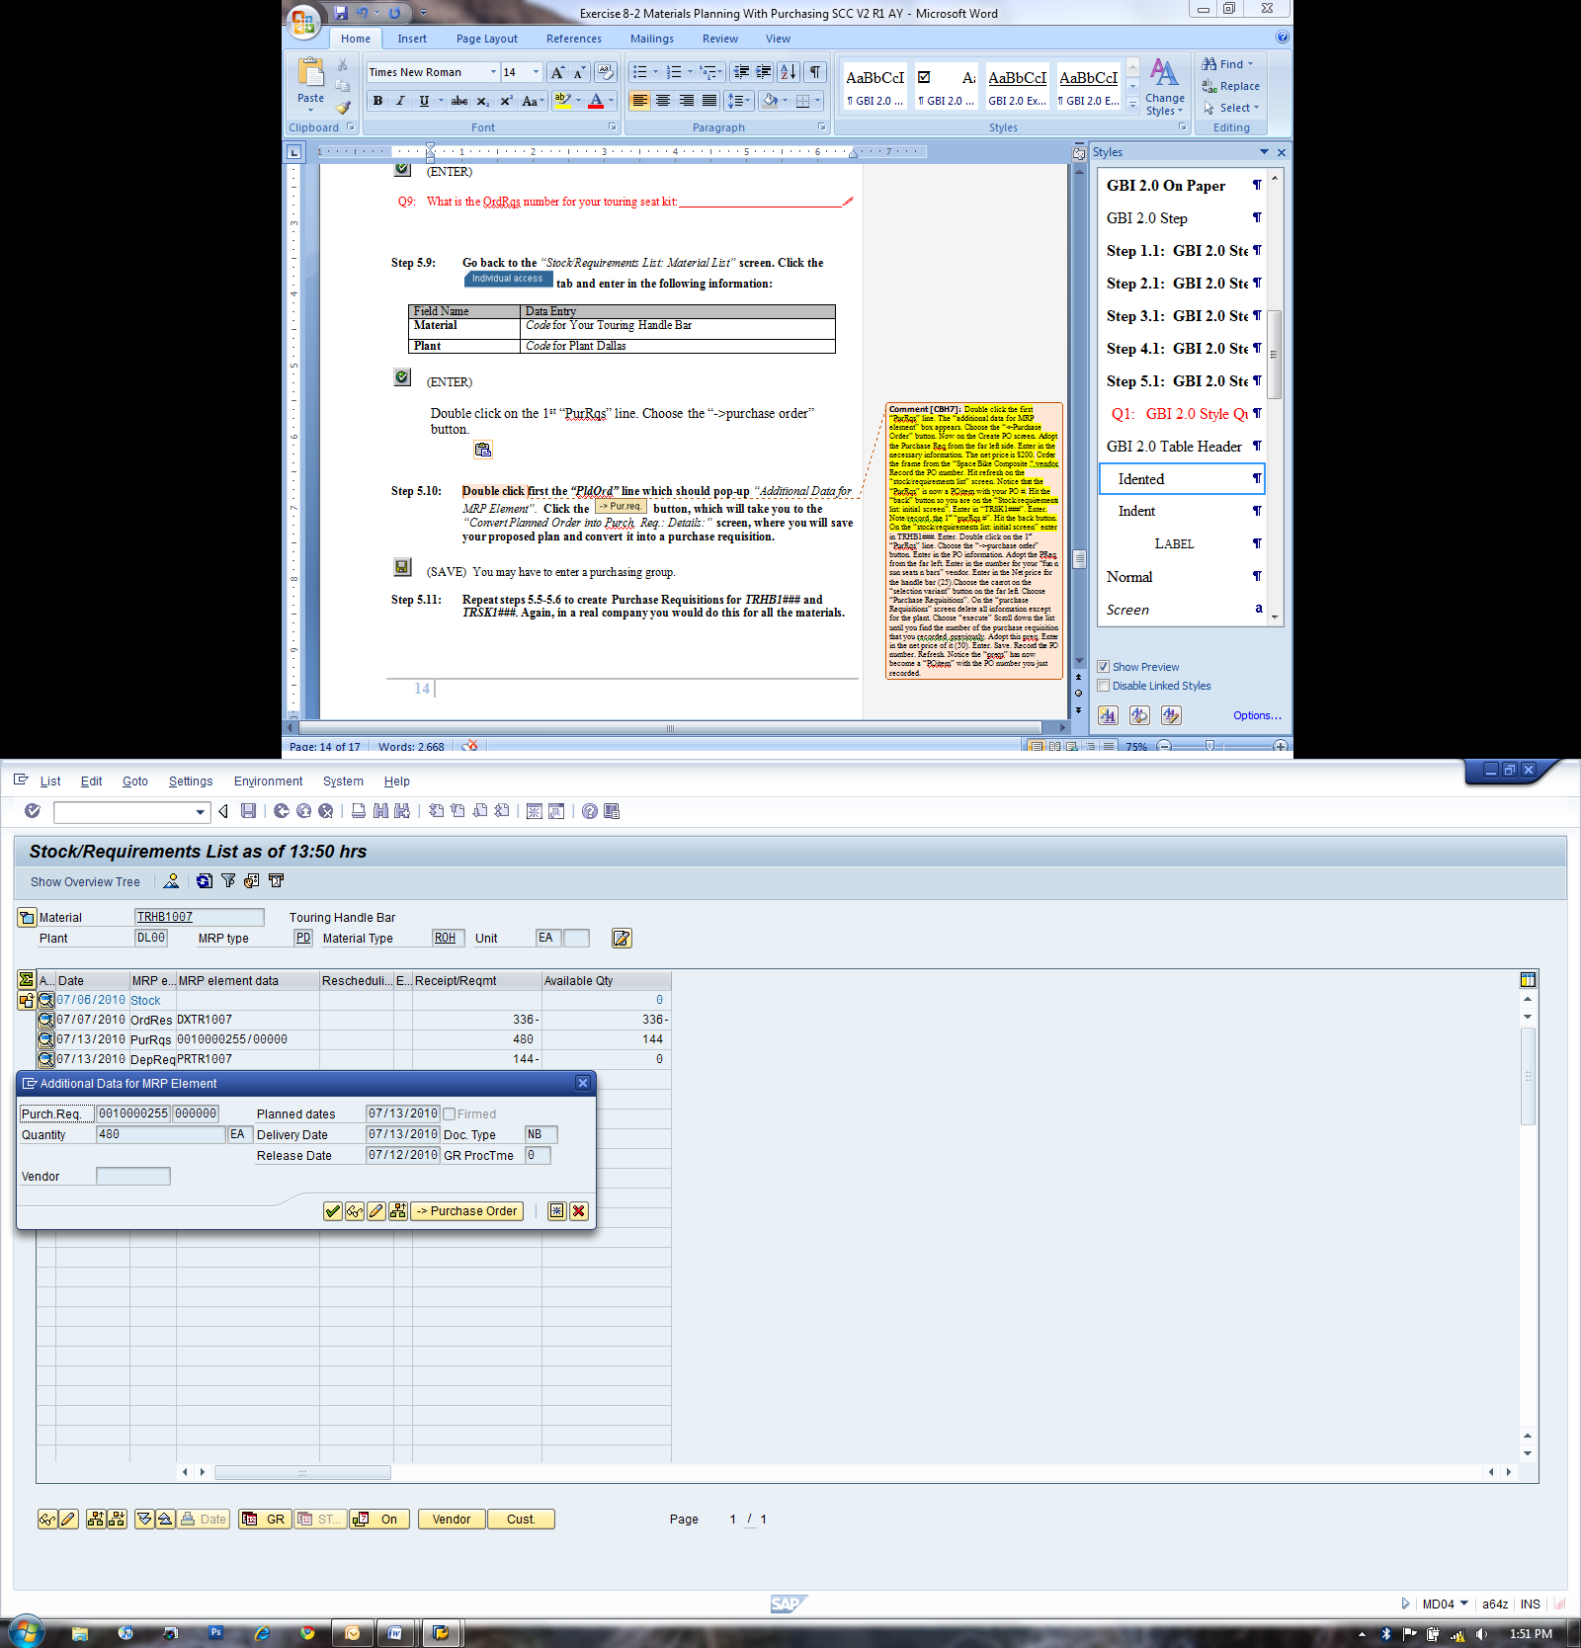 icon. You will receive an error that says “Enter Purchasing Org.”.
4. In the “Create Purchase Order” screen, enter the following information:

|  |  |
| --- | --- |
| Field Name | Data Entry |
| Vendor | Your Space Bike Composites |
| Purch. Org. | Your GBI, Purchasing |
| Company Code | Your Global Bike Inc. |

1. Highlight your purchase requisition number on the left side of the screen.

* DO NOT double-click on the number! If you double-click on the number, the screen will display the purchase requisition and you will have to re-enter the stock/requirement list.

1. Click on  (ADOPT).

You will receive an error that says “Net price must be greater than 0”.

1. Enter the following information:

|  |  |
| --- | --- |
| Material | Net Price |
| **Your Touring Frame-Black** | 200 |

1. Click on  (SAVE).

You will receive a message that says “Standard PO created under the num.”.

1. What is the resulting document number?       🖉

* You are back in the previous screen. Refresh the data by clicking on the  icon. Notice how the order has officially changed from a purchase requisition to a purchase order item.

1. In the “Stock/Requirements List as of hrs” screen, click on the  icon.
2. You are in the “Stock/Requirements List: Initial Screen” screen.

Enter the following information:

|  |  |
| --- | --- |
| Field Name | Data Entry |
| Material | Your Touring Seat Kit |

1. Click on  (ENTER).
2. What is the number of the first purchase requisition for your seat kit?       🖉
3. In the “Stock/Requirements List as of hrs” screen, click on the  icon.
4. You are in the “Stock/Requirements List: Initial Screen” screen.

Enter the following information:

|  |  |
| --- | --- |
| Field Name | Data Entry |
| Material | Your Touring Handle Bar |
| Plant | Your Plant Dallas |

1. Click on  (ENTER).
2. Double-click on the first purchase requisition line.
3. In the “Additional Data for Element” pop-up, click on the  icon. You will receive an error that says “Enter Purchasing Org.”.
4. In the “Create Purchase Order” screen, enter the following information:

|  |  |
| --- | --- |
| Field Name | Data Entry |
| Vendor | Your Fun n the Sun Seats n Bar |
| Purch. Org. | Your GBI, Purchasing |
| Company Code | Your Global Bike Inc. |

1. Highlight your purchase requisition number on the left side of the screen.

* DO NOT double-click on the number! If you double-click on the number, the screen will display the purchase requisition and you will have to re-enter the stock/requirement list.

1. Click on  (ADOPT).

You will receive an error that says “Net price must be greater than 0”.

1. Enter the following information:

|  |  |
| --- | --- |
| Material | Net Price |
| **Your Touring Handle Bars** | 25 |

* Remember that we are procuring two types of materials from this vendor. We will combine two purchase requisitions into one single purchase order. To look for the second purchase requisition, refer to the following steps. They will refer you to the order number you wrote down.

1. Click on 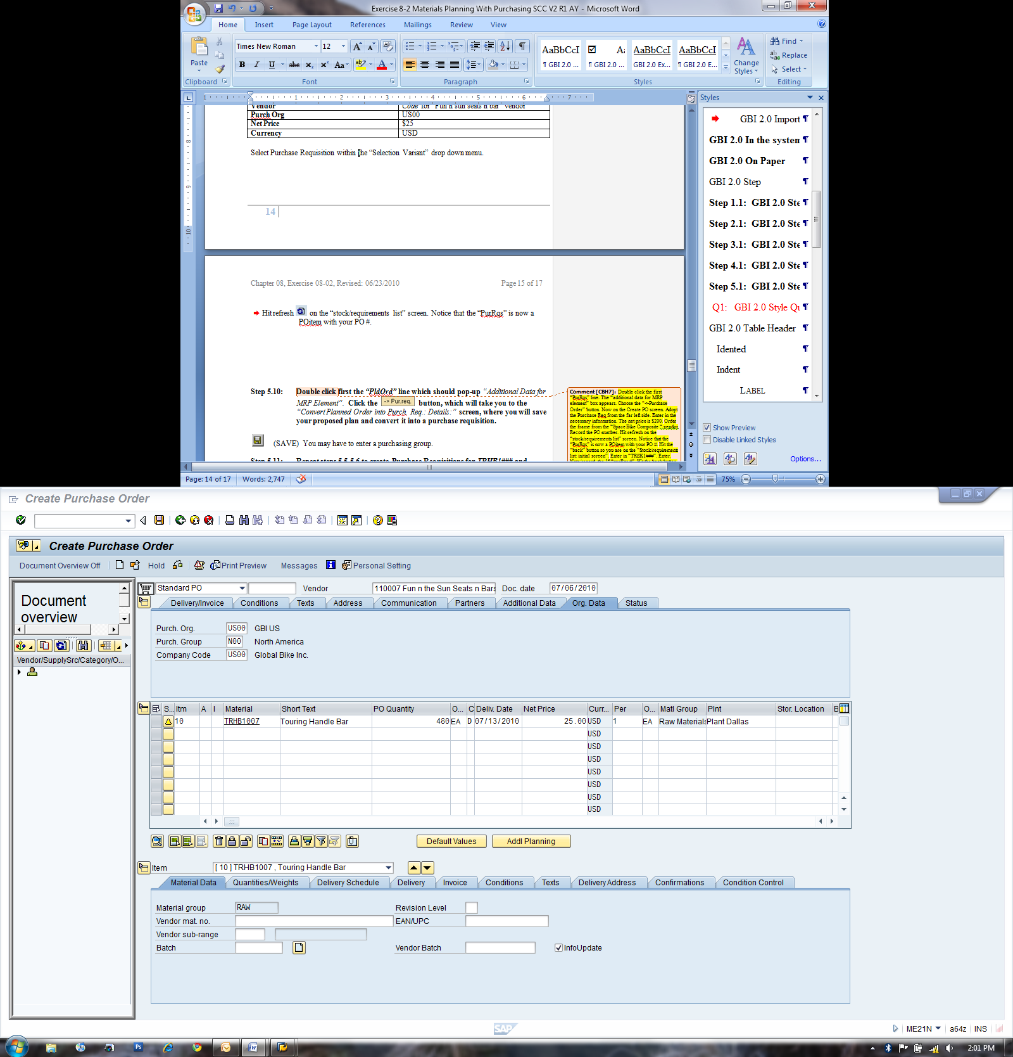 (SELECTION VARIANT).
2. Click on Purchase Requisitions.
3. You are in the “Purchase Requisitions” screen.

Clear out all contents in the entire screen with the exception of the “Max. no. of hits” field which limits the search for 5,000 purchase requisitions.

1. Click on  (EXECUTE).
2. In the “Create Purchase Order” screen, highlight your purchase requisition number on the left side of the screen that you wrote down for your seat kit.
3. Click on  (ADOPT).

You will receive an error that says “Net price must be greater than 0”.

1. Enter the following information:

|  |  |
| --- | --- |
| Material | Net Price |
| **Your Touring Seat Kit** | 50 |

1. Click on  (SAVE).

You will receive a message that says “Standard PO created under the num.”.

1. What is the resulting document number?       🖉

Exercise Deliverables:

In the System:

* Orders Converted

On Paper:

* Answer(s) to Question(s)
* Document Number(s)

Attachment 1: Exercise Worksheet

**Name:** CHAITHANYA KRISHNA CHEEMIREDDY

**Course and Section:** OMIS 643

**Identifier:** GBI-016

**Client:** 555

1. What is the transaction code to change an SOP plan for a product group? 🖉
2. What is the transaction code to break down a product group plan? 🖉
3. What is the transaction code to transfer the groups to demand management? 🖉
4. What is the transaction code for single-item planning, interactive? 🖉
5. How many months are planned for? 🖉
6. What is the transaction code for single-item planning, multi-level? 🖉
7. What is the code for the processing key for this material? 🖉
8. What is the transaction code to display a stock/requirements list? 🖉
9. What is the total quantity planned for this production order? 🖉
10. What is the resulting document number? 🖉
11. What is the resulting document number? 🖉
12. What is the number of the first purchase requisition for your seat kit? 🖉
13. What is the resulting document number? 🖉